St. John’s Evangelical THE
Lutheran Church VISITOR

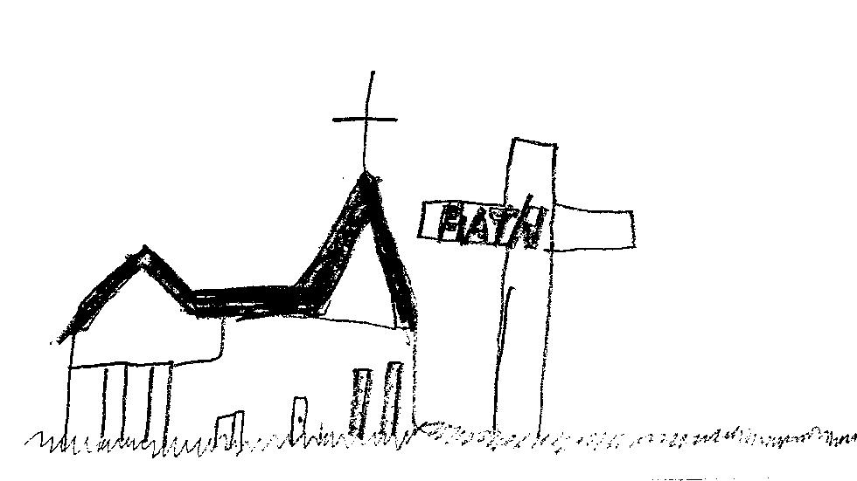
Caden Argall, 3rd grade

______________________________________________________________________________________________________________________________________________________________________

Prairie du Sac, WI June 2019

1 John 3:16–18
By this we know love, that he laid down his life for us, and we ought to lay down our lives for others. But if anyone has the world’s goods and sees his brother or sister in need, yet closes his heart against him, how does God’s love abide in him? Little children, let us not love in word or talk but in deed and in truth.

Our final totals for this year’s stewardship focus are:
Bilingual Resources for District: $9,800
Sauk Prairie Literacy Council: $1,328.62
Madison Reading Project: Over 200 books donated

Because of your generosity, Tower Rock can purchase a leveled library (bilingual resources), along with 40-50 popular books in Spanish AND 40-50 popular books written in Spanish for every elementary school library in our district.

Thank you, St John’s! You have shown love in deed and in truth.



We extend a heartfelt thank you to all those who helped make Sunday School run smoothly this year. Thank you for spending your time and talents with the young people of St. John’s and helping them in their faith journey.

Teachers: Marge Erlandson*, John Hines*, Joanna Jones, Miranda Jager, Keri Thiede, Jennifer Brennan, Linda Yanke, Ellen Jorgensen, Nicole Sandberg, Kelly Ramirez, Paul and Ann Kippley, Mariah Chao, Emma Breunig, Andrea Chao, Chris Stephan, Robin and Ken Lueck, Christina Himebauch, Liz Leith, Jennifer Stephan and Linda Hines

Assistants: Claire Thiede, Audrie Nurkala, Jenna Pistono, Karlie Harpold, Sandy Frey, Anna Bruckert, Ruby Sandeman, Jordan Small, Emily Caflisch and Anna Francour

Substitutes: Maren Anderson-Boerger, Sarah Goetsch, Carrie Richard, Becky Francour and Sandy Larsen

Singspiration Leaders: JoAnnah Sorg, Ruth Lohr, Amber Kelter, Karlie Harpold, Audrie Nurkala and the 6th grade Sunday School class

Superintendents: Katie LaVigne and Megan Tarnutzer

Youth and Education Coordinator: Abby Bennett

*Marge is retiring after having taught Sunday School for 13 years and John is retiring after 11 years of teaching. Thank you both!

thanks!
This year we had some AMAZING Confirmation teachers! It takes special people to teach our Middle School and High School youth, and our teachers this year were excellent. They were: 7th Grade: Haakon Carlson and Kim Larson 8th Grade: Laura Collins, Marv Hupp and Kathy Bruckert 9th Grade: Pastor Fred
Thank you for your dedication to our Youth!
We are currently looking for one additional 7th grade teacher for next year. If you are interested, contact Abby Bennett - abby@stjohnssaukprairie.org


Parish Planning Council Members:
Executive Director Jon Sandeman 643-5006
Assistant Exec Director Janelle Hupp 643-0653
Secretary Kathy Lovell 643-2075
Treasurer Sara Dregney 370-8151
Evangelism Board Sheila Peak Dittberner 370-1550
Fellowship Board Linda Michaels 643-8286
Lay Ministry Board Melani Wheeler 544-2711
Member at Large Linda Lintl 643-9377
Member at Large-Youth Grace Sandeman 643-5006
Parish Education Board James Newman 512-7623
Properties Board Lon Kaderavek 434-2928
PR and Social Concerns Patty Barritt 393-5218
Stewardship Board Anne Klinkner 393-6453
Women of ELCA Marian DeGiovanni 643-4514
Youth Board Megan Tarnutzer 963-0396

The Staff:
Pastors: Fred Rilling on sabbatical leave until August 6
Sally Williams sally@stjohnssaukprairie.org (h) 643-7810
Intern Elisabeth Pynn Himmelman elisabeth@stjohnssaukprairie.org (office) 643-2439
Youth-Education: Abby Bennett abby@stjohnssaukprairie.org (c) 370-2380
Custodian: John Hines john@stjohnssaukprairie.org (c) 393-2325
Office and Communications Coordinator: Linda Hines linda@stjohnssaukprairie.org (h) 544-2409

St. John’s Lutheran Church: 643-2439 www.stjohnssaukprairie.org
Like us on Facebook at St Johns Lutheran Sauk Prairie

Mission Statement: Christ, our strength and refuge, calling us to serve

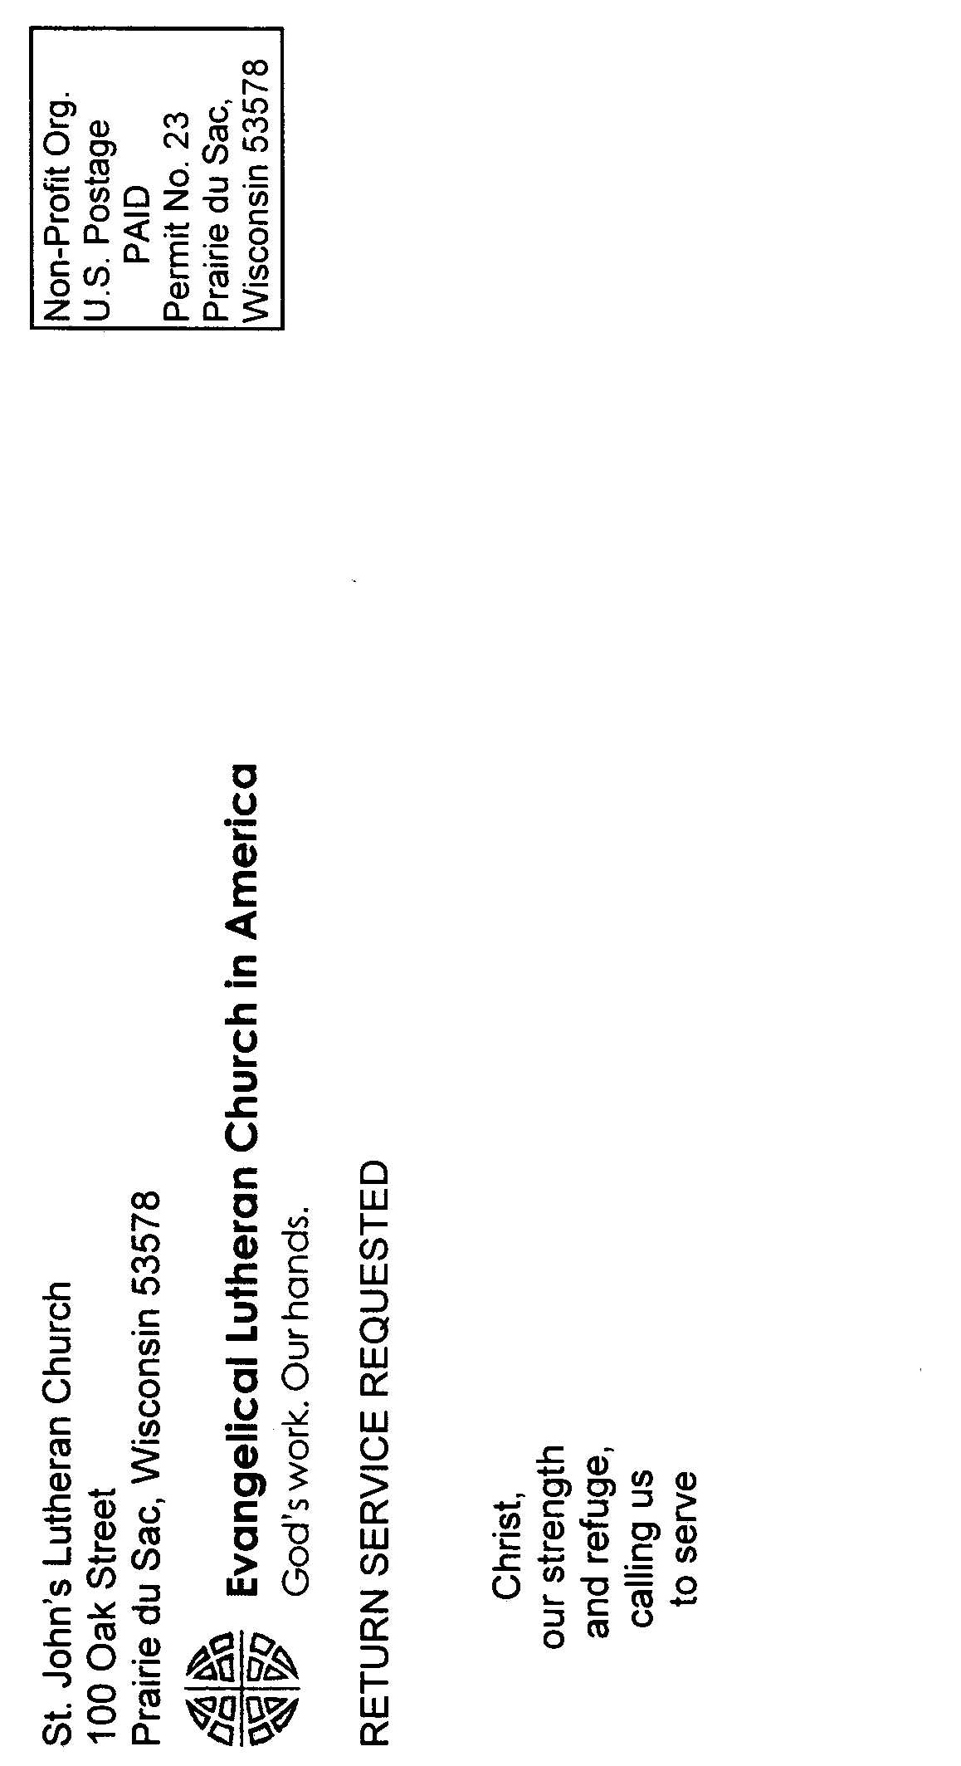


Food Pantry Sunday is June 9. Food, paper products and cleaning supplies may be brought to the table in the gathering area. These items are distributed to many families in the Sauk Prairie community. The food pantry especially needs:

Baked Beans Flavored Noodle Side-dishes
Cookies Flavored Rice Side-dishes
Pudding Cups Cake Mix

Keep this list handy as you do your grocery shopping during the next few weeks.

Many parishioners find it easier to bring the items to the gathering area of the church at other times during the month. We appreciate the donations at any time.



Birthday Greetings
We hope you take a moment to send greetings to the following people who have birthdays in June. The day is in parentheses.

Jan Floeter (7) Anita Key (21)
722 Risley Court Maplewood of Sauk Prairie
Prairie du Sac, WI 53578 245 Sycamore Street
Sauk City, WI 53583

St John’s Work Day
The Properties Board thanks everyone who came to help at our Church Work Day on May 18. We thank: Dale Haroldson, John Ballweg, Wes Oye, Marv Hupp, Janelle Hupp, John Hines, Lon Kaderavek, Mike Wernsing, Jon Sandeman, Roger Clason, Darlene Holl, Marian DeGiovanni, Tony DeGiovanni, Mary Weeks, Elisabeth Pynn Himmelman, Jens Himmelman, Sally Williams, Sheila Peak-Dittberner, Roger Seymour, and Gwen Ringlestetter. Your help is greatly appreciated.
Women of the Church News (WELCA
In May, 33 Ladies attended Circle meetings with Dorothy Halverson, Marilyn Larson, Marian DeGiovanni, and Jan Floeter leading the Bible Study. In June, Carol Benson, Mary Weeks, Loretta Landerman and Kathy Lester will be leading the Study.
It was indeed SO EXCITING to see so many people at the WELCA Baraboo Conference on April 27th. The total number was 57 and we think that is some kind of record. We started with registration, coffee and goodies at 8:30 a.m. Then we began our program at 9:30, with a welcome by President Marian DeGiovanni. The first hymn was “Spirit of God in the Clear Running Water”, which introduced the theme of always inviting the Holy Spirit into our lives. This was followed by Devotions with that same theme, given by Intern Elisabeth. Another meaningful hymn, “Spirit of the Living God, fall afresh on me…melt me, mold me, fill me, use me” was sung. It was all a very inspirational beginning to our gathering. It was very fitting that Marian and Tony DeGiovanni introduced our guest speaker of the day, Kathy Roberg, RN, of the Haiti Medical Mission of Wisconsin. Tony and Marian were involved in the HMMW almost from the very beginning. When Tony first began to do surgery there, he was sometimes working on dirt floors by the light of a spotlight using a generator. He fell in love with the people there, who are the poorest of the poor. In 2001 the HMMW built and furnished a medical clinic in Thiotte (pronounced Chote), and began treating patients there in 2002. Now Thiotte also possesses a hospital and continuous medical care is available. Tony and Marian have made many trips to Haiti and have inspired many other volunteers, one of them being Kathy Roberg. Kathy asked Tony how many trips he made and he answered “14”. She said she now has about caught up with him. The people there are so appreciative of everything they do for them. It is a reminder to the volunteers that they are important. The Haitian people are so poor and malnourished. When they get so badly malnourished, their hair gets a reddish tint. Sometimes they do not have food for days. There is no electricity and they wash their clothes in rivers or streams. Volunteers provide their own air fare (which is about $2,000) and they also have to use their vacation time from work. From Port au Prince to Thiotte it is about 51 miles, but it is a 4 ½ hour very rugged trip on a road cut out of a mountain and through a river bed. 61% of the people there are illiterate. Those who do get to school pay $35/year tuition. They have uniforms, which is good because that also helps them feel like they “belong”. They have to use kerosene for cooking and kerosene is hard to come by. Kathy’s talk was so very interesting and she allowed for questions afterward. Everyone enjoyed it very much. Kathy and the DeGiovannis have such a love for the people of Haiti and will always have a soft spot in their hearts for them. We are so grateful to them for what they do and for the wonderful presentation at our meeting.
After Kathy’s talk, Synodical WELCA Board members Hildy McGown and Janean Hill gave us important information: Be sure to mark your calendars for Saturday, September 21, 2019 for the Biennial Convention at Good Shepherd Lutheran Church-Verona Campus, beginning at 8:30 a.m. This will include speakers, workshops, worship and lunch. Cost is $25. Registrations are due by September 9. Rev. Angela Khabeb will be the keynote speaker. She spoke at the 2017 Triennial Convention. Go to https://www.womenofthe elca.org/triennial-videos to hear that sermon. She is a very dynamic speaker. Also, be thinking about the Triennial Convention which will be held in Phoenix, July 14-16, 2020. We voted to give the $100.05 left in the treasury of the Baraboo Conference to the Haiti cause.
Eunice Yanke, Treasurer, announced that the amount of the offering for the day was $716. $250 will go to the Synod and $500 will go to HMMW (adding some money from our budget to make it even).
St. Peter’s Lutheran Church in Loganville will be the host church for the Spring 2020 Baraboo Conference.
After the meeting and table prayer, we all proceeded to the dining room where Donna Nelson and her helpers had prepared a wonderful, fabulous meal of roast beef and gravy on potatoes, vegetable and fruit salads, her delicious home-made bread, desserts and beverages. She and her helpers gave us such great service and we can’t say enough about Donna and her graciousness! She also provided us with the beautiful daffodils that were on the tables.
Martha Circle is visiting Special Friends during April and May. Sarah/Mary Circle will visit them in June and July.
SAVE THE DATE: Thursday, July 18, 9:30 a.m. for the Summer Picnic at the Blue Spoon. Intern Elisabeth will lead the Bible Study for us and we will have some musical entertainment. There will be a free-will offering for the meal. (Suggested amount of $5.00) Please bring a guest.
There will be no Bible Study Leaders Meeting for July.
Read this month’s Prayer for Peace found in this Visitor on June 20.

Women of the Church News (WELCA)
Hannah Circle: No meetings during summer months
Lydia Circle: Thursday, June 13, 1:00 p.m. at Carol Mallon’s, N1617 Fjord Circle, Prairie du Sac
Martha Circle: Thursday, June 6, 9:00 a.m. at Mary Weeks’, 273 Park Avenue, Prairie du Sac, Marge Erlandson, Hostess
Ruth Circle: Monday, June 10, 9:00 a.m., at Jan Dobrzynski’s, 50 Hemlock St., Unit 1, Sauk City
Sarah/Mary Circles: Tuesday, June 4, 1:30 p.m. at St. John’s Library

Women’s Book Club 
The Women’s Book Club will not meet during the summer months. They will return to discuss The Readers of Broken Wheel Recommend by Katarina Bivald in September.

Older Wiser Livelier Seniors (OWLS)
All 55+ members and friends of St. John’s are invited to gather together at 9:30 a.m. on Thursday, June 20. Our speaker will be Shirley Kelter. We hope you can join us!
If you need a ride to the OWLS gatherings, please call Darlene Holl at 643-8413.
OWLS will not meet during July or August.

Adult Education
Adult Education will not meet June, July, and August, but you are encouraged to continue your own study and conversation with one another informally. We will resume our group study together in September!

Text Study
Text Study will meet June 5 through July 17 (Wednesdays) at 10:00 a.m. Come for a discussion of the readings for the next Sunday. Text Study will not meet in August.

 New Member Exploration
Every year we are delighted to welcome new members to our congregation. As part of our new member process, we feel it is important that our new members (as well as our current members) have the opportunity to learn more about our history as the Lutheran Church, how it is structured, and what it means to be stewards and members of God’s Church as well as of St. John’s.
Please plan on attending our Wednesday evening sessions on June 5, 12 and 19 at 6pm.
The official New Member Installation and Reception will take place on Sunday, June 23 at the 9:30am service.
We hope you will take seriously our invitation to engage in this congregation as though you are already members. You are welcome to attend adult education classes, get involved in the work of one of our boards, volunteer to help with worship, and attend any congregational events.
Please contact Pastor Sally Williams with any questions or concerns.



We invite you to pray for peace on the 20th day of each month. On June 20, please repeat the following prayer:

We ask for your forgiveness, Lord,
when we forget the power that lies within,
and trust instead upon our human strength.
Remind us of that glorious day when your Spirit
transformed the lives of those who hid in fear,
into men of power.
Renew these hearts which have grown cold
with flames of fire, as on that Pentecost,
that we might be the church that you desire.
Amen.

With Sincere Sympathy 
We offer our condolences to the following families this month:
Fred and Brenda Schweitzer and family on the death of Fred’s Godmother, Sharon Sturdevent. We also pray for Brenda and Fred, and Caroline Morrow on the death of Brenda’s cousin and Caroline’s nephew, Bill Meili.
Nadine and Bryce Lauer and family on the death of Nadine’s mother, Virginia.
Please keep these families in your prayers.


We recently received monetary gifts in memory of Daniel Fruehling, Dorothy Hamre and Carolyn Yanke. We are grateful when our congregation is remembered in this manner. These gifts will be used to benefit the ministry of our church.

 St. John’s reports many of the names of our hospitalized and recently discharged members in the monthly newsletter. We include only those who have given us permission to print their names. You may send cards or telephone them and pray for their improved health.

Hospitalized/Recently Discharged

Sue Hitchcock

 Wedding Congratulations

We rejoice with Hayley Pippin and Brandon Barry who were married at St. John’s on May 4.
Please pray for them and all newly married couples as they enter this new milestone in their lives.

We welcome these new brothers and sisters into the family of Christ following their baptisms during the month of May.
Paisley Leeann Stuettgen, daughter of Brody and Jenna (Lovell) Stuettgen. Paisley was baptized on May 12 and her sponsors are Kelsey Gilbertson and Austin Stuettgen. Paisley’s congregational sponsors are Tom and Gina Varley.
Eli Davis Emerson, son of Tyler Davis and Alyssa Leann (Laskaris) Emerson. Eli was baptized on May 19 and his sponsors are Amber More and Hailey Oehlke. Eli’s congregational sponsors are Nick and Sarah Goetsch.

Ordination Anniversary 
Many of you know Rev. Eldor Fruehling. You may know him through his 26 years of service on the Prairie du Sac Village Board or from his periodic teaching and leading of worship here at St. John's. If you have been a member for more than 27 years, you also know he served as pastor to this congregation from 1957 until he retired in 1992. Prior to coming to St. John’s, he also served Christ Lutheran Church in LaMars, IA from 1953-1957. He graduated from Wartburg Seminary in Dubuque, IA, and was ordained on July 5, 1953. Please remember Eldor on his 66th ordination anniversary.

Thank you!

Dear St. John’s Lutheran Church,
Thank you for your generosity and support of the mission of Wartburg Seminary! Your thoughtful gift is an investment in the future of the church and its congregations.
Your recent gift of $1,000 will greatly benefit students called to ministry through Wartburg Seminary. Without your partnership, we would not be able to provide future generations of faith leaders with the resources they need to serve the church for years to come.
In Christ,
Rev. Louise Johnson, President


Dear Sisters and Brothers in Christ,

Another school year is coming to an end, and we have so many reasons to celebrate. One reason that has had a resounding impact on my year is your generosity, St. John’s.
For those of you who weren’t able to be here when Ms. Kelly Petrowski, principal of Tower Rock Elementary, visited our congregation I will share with you a little snippet of her words:

Last week I had the privilege of offering some Spanish lessons to various homerooms at Tower Rock. I used one of the books that we purchased with your donation for a kindergarten lesson. I started reading in Spanish, and immediately, I saw the native Spanish speakers’ faces light up like I haven’t seen before. A normally reserved, quiet student was so eager to answer my questions and read along with me - I could barely contain her excitement - she was shouting out, answering questions, talking a mile-a-minute. That excitement - that feeling of letting the words just flow out of her mouth without thinking - it’s because of this congregation and your donations. We have purchased books that could be used for reading groups. We have purchased books that could be used for read-alouds. We purchased non-fiction books. We ordered authentic literature, written by authors from Argentina, Nicaragua and Mexico. We are ordering novels - everything from Diary of a Wimpy Kid to Harry Potter to Big Nate to Judy Blume books - all in Spanish. It’s really incredible, this gift you have given us.

Incredible indeed.
A reminder that as a thank you, the Tower Rock community has invited us to an open house at the school on Thursday, May 30th at 4-5:30pm. Many of us will gather at the church to carpool, while others will meet us there. This is more than just a tour. This is an opportunity to further our partnership with the families and employees of our district. A sign-up sheet has been placed on the kiosk. You can also rsvp to me via email at sally@stjohnssaukprairie.org. I hope to see you there!

With sincere gratitude,

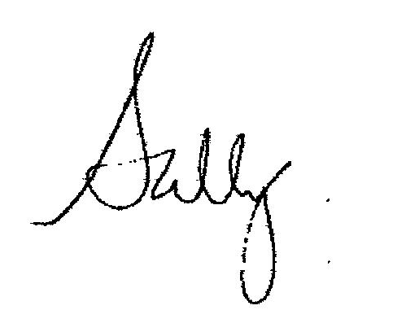
 Greetings Siblings in Christ,

Summer is coming! For high school grads, it’s already here! For me, this is a season of thinking about endings and beginnings, as I wrap up my time with St. John’s on July 21. As I look around, I see beginnings and endings all around us. It makes me think about the kindness of the people in this faith community, and how I’ve seen it play out with the youth in this place. This is a very supportive congregation, full of love and care for one another. A humble thank you for saying “yay!” to interns, to young people, to loving the least of these. I’m astounded by the totals of our yearlong stewardship project and by the generosity God has given the people in this place!
So, thank you. It isn’t always easy to be a place that gives generously not only of your own financial abundance, but of your spirit. You graciously respond to God’s love by saying “yay!” to the creativity of the Holy Spirit when…
You call young people by their first name.
You affirm all that is good among learners among us… from Sunday school children to interns to those wise in age and years.
You tell young people's parents all you see that is good about the kids they are raising in this world.
You share your stories of life, faith, experience, and wisdom. even in those moments you don’t feel heard.
You listen to the story of how you can respond to God’s love through literacy and give nearly $10,000 to the cause as a congregation.
And so much more!
Thank you for saying, "yay!" in response to God’s love in countless ways.
In Christ,
Intern Elisabeth

Congratulations!

Traci Schutt, member of St. John’s, was recently awarded the Crystal Apple Award for her work as a 6th grade teacher at Sauk Prairie Middle School. Congratulations Traci!


Happy June Birthday!
The day is in parenthesis

Our Youngest:

Eleanor Muehrer (3) Emma Kraus (4)
Allie Lochner (8) Harper Kirk (15) Roman Koenig (16)

Our Sunday School Students:

Kya Pickarts (1) Sara Francour (4)
Gavin Goetsch (4) Sophia Vest (4) Jacob Lins (6) Owen Louis (7) Samuel Krueger (8) Collin Lins (8) Alexis Graber (9) Liam Hart (9) Jenna Shimpach (9) Mason Ramirez (15) Tori Breunig (16) Alyssa Himebauch (16) Michael Jolicoeur (16) Dominick Desso (20) Reese Bletsch (21) Carson Lohr (24) Charles Lueck (24) Cameron Ederer (28) Chloe Graber (29) Lee LaVigne (30) Olivia Wiese (30)

Our Youth:

Cora Dunnum (7) Austin Keyser (7) Cole Douglas (8) Jace Elsing (9) Natalie Ballweg (12) Zach Guentherman (16) Dylan Quayle (16) Leah Froehlich (17) Trevor Harms (18) Ava Shimpach (19) Alia Schlimgen (20) Brody Ballweg (22) Gabe Harter (22) Wesley Himebauch (29) Jenna Pistono (29)

College and Career-age Young People:

Evan Schmit (9) Lauryn Froehlich (12)
Gracie Koenig (14) Tyler King (16)
Jacob Braxton (27)

Serving in June

Ushers: 8:00 a.m. 9:30 a.m.
June 2 Austin Bruckert Lily Fauerbach
Anna Bruckert Rhonda Fauerbach
Rodney Key Gerry Westphal
Marsha Key Deb Westphal
June 9 Emily Luther Chloe Wernsing
James Wendt Mike Wernsing

June 16 Lauren Endres Nurkala Family
Michael Endres Colby Frey
Craig Frey

June 23 Ethan Jones Ava Shimpach
Andy Jones Emily shimpach

June 30 Lily Fauerbach Andrew Deuman
Rhonda Fauerbach Sara Deuman

Acolytes: 8:00 a.m. 9:30 a.m.
June 2 Wesley Himebauch Colin Wernsing
Kennedy Colby Andrew Deuman
June 9 Karlie Harpold Colin Wernsing
Landon Schultz Ava Sandeman
June 16 Brody Ballweg Jay Dregney
Josie Frey Hannah Stephan
June 23 Wesley Himebauch
Josie Frey Kate Himebauch
June 30 Anni Braund Wesley Himebauch
Thea Harpold Natalie Ballweg

Readers: 8:00 a.m. 9:30 a.m.
June 2 Jack Boerger Chloe Wernsing
June 9 Bev Clason Becki Braund
June 16 Dan Baun Dale Clason
June 23 Roxanne Zick Arthur Ness
June 30 Roxanne Zick Dale Clason

Cantors: 8:00 a.m. 9:30 a.m.
June 2 Megan Small Becky Weittenhiller
June 9 Pastor Sally and Intern Elisabeth
June 16 Melani Wheeler Melani Wheeler
June 23 Marv/Janelle Hupp Deb Lohr-Foster
June 30 Karley Blau Amber Kelter
Communion Assistants: 8:00 a.m. 9:30 a.m.
June 2 Jack Boerger Andrew Deuman
Kathy Lovell Chloe Wernsing
June 9 Bev Clason Dale Clason
Roger Clason Dede Egan
June 16 Josie Frey Audrie Nurkala
Donna Knickmeyer Deb Westphal
June 23 Crystal Lautenbach Audrey Luetscher
Roxanne Zick Bill Wardwell
June 30 Linda Hines Dale Clason
Marilyn Herschleb Audrey Luetscher

Assisting Ministers: 8:00 a.m. 9:30 a.m.
June 2 Chloe Wernsing
June 9 Donna Knickmeyer
June 16 Audrie Nurkala
June 23 Marv Hupp
June 30 Jordan Small

Communion Set Up/Clean Up 8:00 a.m. 9:30 a.m.
June 2 Jayne Carlson Deb/Gerry Westphal
June 9 Kennedy Colby Schonenbergers
June 16 Deb Corrao Himmelman family
June 23 Linda Meyer Dale/Dave Clason
Judy Tobias
June 30 Linda Hines Himmelman family

Nursery Staff: 8:00 a.m. 9:30 a.m.
June 2 Colby Frey Emily Luther
Thea Harpold Randy Trudell
June 9 McKenzie Lautenbach Malea Schonenberger
Thea Harpold Chesney Schonenberger
June 16 Eliot Carlson Lauren Endres
Nick Dunnum Eliot Carlson
June 23 Addison Douglas Hannah Stephan
Dylan Quayle Lily Fauerbach
June 30 Kate Himebauch Anna Francour
Andrew Deuman Kyra Manning

Coffee Set-Up/Clean-Up: 7:30 a.m. 9:00 a.m.(Serve)
June 2 Josie Frey
June 9 Austin/Anna Bruckert
June 16 Linda Yanke
June 23 Ava Sandeman
June 30 Hannah Stephan

Sunday Stewards 8:00 a.m. 9:30 a.m.
June 2 Janelle Hupp Linda Michaels
June 9 Anne Klinkner Marian DeGiovanni
June 16 Linda Lintl Marian DeGiovanni
June 23 Sheila Peak-Dittberner Jon Sandeman
June 30 Patty Barritt Marian DeGiovanni

Greeters: 8:00 a.m. 9:30 a.m.
June 2 (Sanctuary) Don/Vi Bohler Dave Clason
(Front doors) Steve/Holly Kindschi Cory/Nicole Mittenzwei
(Side doors) Bruce/Pam Pickens
June 9 (Sanctuary) Linda Lintl Bob/Dede Egan
(Front doors) Karen Bader Jackie Frosch
(Side doors) Dick/Jan Dobryznski
June 16 (Sanctuary) Landon Schultz Randy Trudell
(Front doors) Jack Boerger Eliot Carlson
(Side doors) Eliot Carlson Brody Ballweg
June 23 (Sanctuary) Jeannine Robertson Dan/Janis Baun
(Front doors) Roxanne Zick family Dave/Ruth Lohr
(Side doors) Roger Maynard
June 30 (Sanctuary) Dan/Kathy Lovell Wolfgang/Diane Reich
(Front doors) Fay Rentmeester John/Aletha Ballweg
(Side doors) Roger/Bev Clason

Congregational totals
Attendance Offering
April 28 381 $6,314.50
May 5 231 $7,795.36
May 12 373 $7,317.30
May 19 243 $9,626.00

Thank you for your continued support, Stewardship Board

 Mobile Meals Delivery
St. John’s will deliver Mobile Meals during the weeks of June 10-14 and June 17-21. See the kiosk in the front gathering area for a sign-up sheet to volunteer. Two people are needed each day – one driver and one runner.
Middle and High School News

Congrats to Anna Bruckert, Lily Fauerbach, Matthew Johnson, Dylan Quayle, Jay Dregney, Ethan Jones and Courtney Lautenbach for completing your sermon notes!

Affirmation of Baptism 
The following young people affirmed their faith on May 12. Please keep them in your prayers and congratulate them on achieving this milestone of faith.

Quinn Baier Malea Niesen
Eleri Fester Ashley Pape
Jackson Gorsuch Alia Schlimgen
Scott Graves Jacob Schweitzer
Samantha Johnson Megan Small
Emma Kinnamon Claire Thiede
Meadow Liedtke Gavin Tompkin
Drew Marshall Wyatt Urban

High School Graduates
The following students were recognized on May 20 for graduating from high school. Keep them in your prayers as they move forward in the new stages of their lives.

Sara Bradley Grace Sandeman
Mariah Chao Noah Schoepp
Rachel Collins Emily Schutt
Nathan Janisch Joshua Schweitzer
Bethany Johnson Jordan Small
Julia Jones Taylor Tompkin
Kyle King Joe Treinen
Sawyer Ladd Jacob Vieth
Cameron Manning Craig Wernsing
Madison Marshall Katie Yanke
Elisabeth Miller
Young Adult Updates
Please keep our young adults in your prayers as they study in college or technical school, travel, and begin new trades and careers.

Paige Beattie was inducted into Phi Alpha Honor Society at UW-Whitewater

Paige Pistono has been honored with a full ride scholarship as she studies for her Ph.D. in Chemistry at the University of California, Berkeley.

Dr. Krista Grinde will complete her pediatric residency training in June and has been accepted as a fellow in pediatric hematology/oncology at the University of Wisconsin American Family Children’s Hospital in Madison.

Kali (Larson) Maniam graduated from Ross University School of Medicine with a Doctor of Medicine degree.

Caleb Sisbach received his BSN from Marian University. He will be studying to become an RN.

New job? Accepted into a new program? Won an award? Need prayers for something specific? Please email Pastor Sally sally@stjohnssaukprairie.org or message her on Facebook with any updates, so that we may continue to celebrate and pray for you in your life in Christ.

 Looking Ahead
- Worship times have changed to 8 and 9:30 a.m. and will remain so through Labor Day weekend.
- Pentecost is June 9.
- St. John’s staffs Mobile Meals, June 10 – June 14 and
June 17 – June 21.
- A Congregational Picnic is Sunday, June 30.
- The WELCA Picnic is July 18 at the Blue Spoon.
- Intern Elisabeth’s Last Day at St. John’s is July 21, we will have a 9:00 a.m. service only that day
- Bible School is August 5-9.
- Pastor Fred returns from Sabbatical August 6.
- Sunday School Rally Day is September 8.
- LWR Boxcar Loading Day is September 14.
Senior Choir Director
We are delighted to welcome Ruellene Seymour to the St. John's staff as the director of the Senior Choir for the 2019-2020 academic year. As part of her responsibilities Ruellene will also serve as the coordinator of special music.
If you are interested in playing an instrument or singing in worship, please contact Ruellene at rrcmor@gmail.com or 608-588-3198. Ruellene’s position does not include rehearsal and accompanying special music for worship, so please make other arrangements with our Sunday morning leaders. Ruellene can help connect you with them.
We are grateful that Ruellene continues to share her gifts for musical leadership with God's people. Welcome, Ruellene!

Worship Time Change 
We have changed to our summer worship schedule. Services will be at 8:00 a.m. and 9:30 a.m. from Memorial Day weekend through Labor Day weekend.
Congregational Picnic in the Park 
Come one, come all to St. John’s Summer Picnic! Sunday, June 30 @ 11am-1pm, Marion Park - East Shelter (facing 1st St. with access to handicapped accessible restrooms). Pack your own picnic. The Fellowship committee will provide lemonade, water, and a few treats. Bring lawn games or simply yourselves! If it rains, we’ll reschedule.

Stock the Schools
Working with the Sauk Prairie Community, St. John’s is collecting items to be given to Sauk Prairie students in need. Each month we will have different items to collect that will help our local students. Some of these items can be used in school and some at home. June’s items are: jars of Peanut Butter and Jelly, and New or gently used Leggings and Sweatpants (sizes child 6 up to adult 2XL). Look for the red bin in the gathering area by the church office to drop off your donations.
 Columbarium

We have heard from the Eickhof Columbarium Company and our columbarium is nearing delivery! We are expecting to get an exact date soon, but are looking for delivery to be in the early part of June. Steve Yanke has our foundation ready as we anxiously await its arrival. Watch the bulletins (and the Memorial Garden) for further updates.

thanks!
Thank you to Roger Seymour and Carisolo Knife Sharpening of Blackhawk for new knives for the kitchen, sharpening the old knives and sharpening our sewing scissors. We are truly grateful!
St. John’s Fellowship Board and St. John’s Quilters


St. John’s Lutheran Church,
Thank you for your gift of $38,749.45 to Mission Support for the South-Central Synod of Wisconsin. We are grateful for your congregation’s commitment to our synod’s ministry.
Through mission, leadership development, care of congregations and global and ecumenical relationships here in the South-Central Synod of Wisconsin and in partnership with the ELCA, we are making a difference in Jesus’ name locally, nationally and globally.
My gratitude to the members of your council and your congregation for the help in being Church Together. Thank you for your generosity in doing this amazing work.
Bishop Viviane Thomas-Breitfeld
Funds sent from our Benevolence budget collected in 2018

 thank you
The Rosenstiels are ever-grateful for our St. John’s family! We continue to give thanks to God for all of your support, love, and prayers as we continue to follow where this call is leading us. We would not be here without all that you have given us. We are especially grateful for the anonymous beloved member or members of St. John’s who sent Derek a surprise graduation banner which is absolutely beautiful and so personal. We continue to hold you all in our hearts wherever we go, and this banner will make your presence with us even more tangible! Thank you so much our siblings in Christ! We love you and miss you all!



Oak Street Road Construction Update
We have certainly seen some changes to Oak Street this past month! The old asphalt has been removed, old curbs, gutters and driveway aprons dug up and taken away and new water pipes installed. We have been driving on gravel since the removal of the asphalt. We have felt the building shake while the machines were packing down the gravel. We were limited to one driveway while new curbs and gutters were poured for the other two driveways. Today those new curbs have cured and we are now able to use our “middle” driveway for access to the parking lot. BUT, we have been able to meet Sunday mornings for worship and fellowship. We have not had our water, power or telephones disconnected. We have been able to continue our normal work schedules, meetings, classes and get-together times. We were able to host the A/P tests (plus a few make-up test days). We have been able to offer our building for the Sauk Prairie School District’s 18-21 year olds group to use while their usual class area is under remodeling. All in all, we are blessed with a good construction crew doing their best to help us through this challenge and blessed again with the patience and understanding of the wonderful people of St. John’s.

